Practicum Case | 
COMP7116 | COMP7116001 | COMP7116016 | MATH6168 | MATH6168016
Computer Vision
Computer Science | O221-COMP7116-NC01-02
Valid on Odd Semester 2024/2025 | Revision 00

Learning Outcome
- LO1 – Describe various computational principles and standard image processing operators in computer vision

Topic
- Session 2 – Statistical Description of Image

Sub Topics
- Histogram Equalization
- Plotting

Soal
Case
BrightSouls
BrightSouls is an MMORPG game that is about to released and is currently being polished before release. Since BrightSouls takes their sceneries very seriously, the developer of BrightSouls is asking for your help to make their background artworks more visually appealing and vibrant. The developer informs you that you can use Python to achieve this. As an experienced programmer, you thought of using Histogram Equalization to help create a more immersive gaming experience by bringing out the richness and depth of the background. Also, don’t forget to create a plot that compares the intensity of the former background and the enhanced background to show the developers of BrightSouls later on.
- Histogram Equalization
- Make a program that can turn the original image into a grayscale image. Then, make sure to equalize the image and show both images side by side to compare the image before equalization and after equalization.
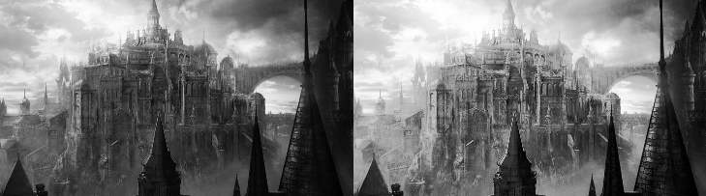
Figure 1. Example of Image Equalization
- Plotting
- Make a program to plot the histogram of the original grayscale image and the histogram of the equalized image, which shows the distribution of pixel intensities before and after equalization, giving insight into how the intensity values have been redistributed to improve contrast.
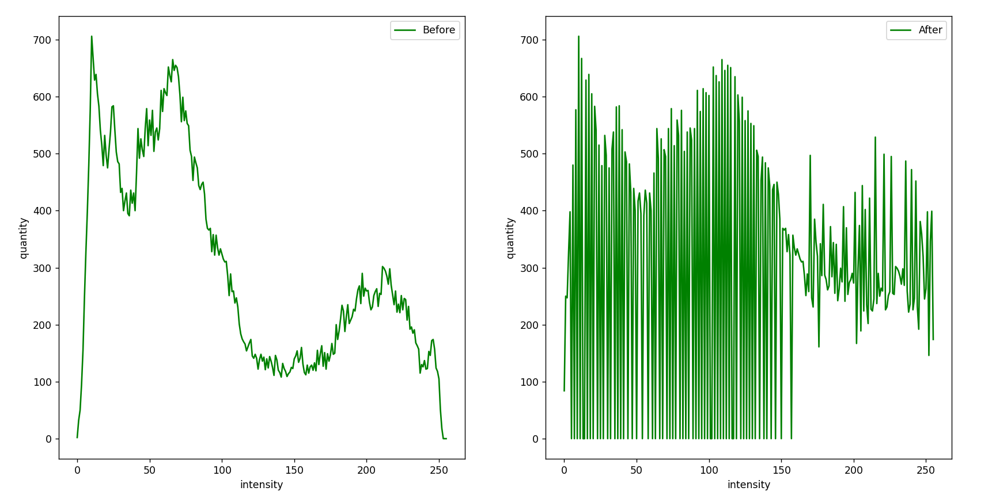
Figure 2. Example of Histogram Plotting

